Assignment 2 Report

Rong Wan

The UML diagram is at the root folder, and below is a screenshot of the diagram in case the file is corrupted.

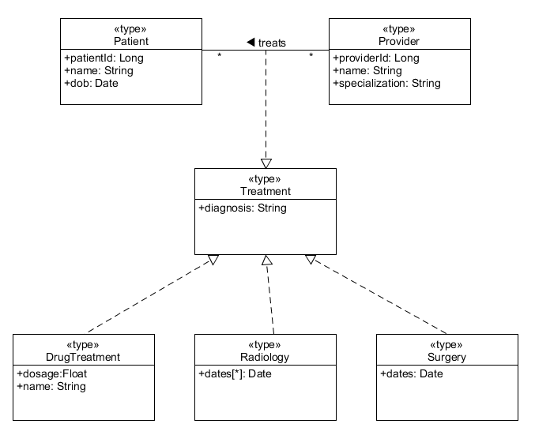

The xsd files are written using Eclipse, and they are in the src folder of each of the three Eclipse projects.

The general structure is similar to the demonstration, while two other techniques are used to provide the variety of treatments. Below are the code segments of the xsd files.

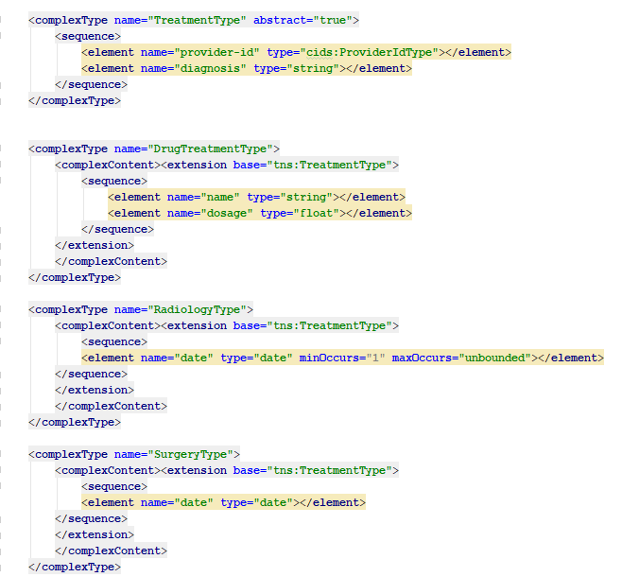

The type substitutability solution

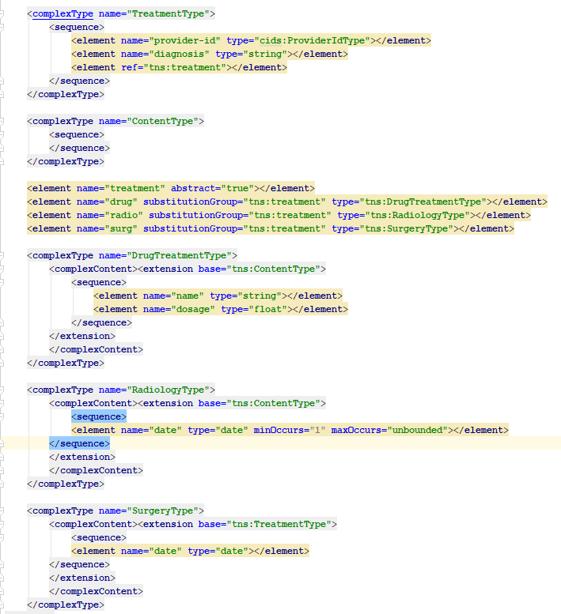

The element substitution solution

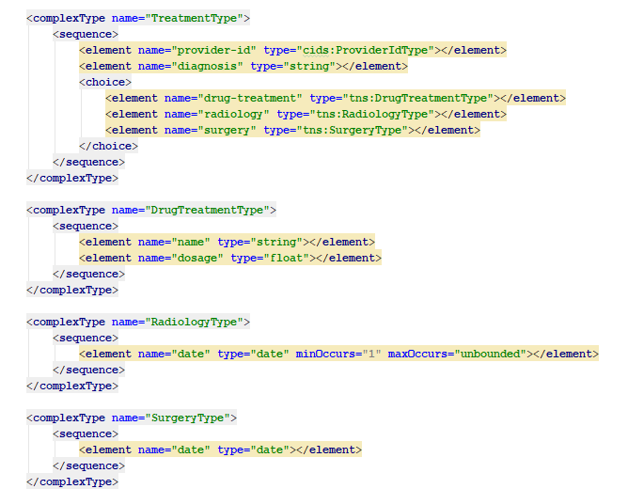

The choice element solution